**DOTA2 Recent Game Analyzer**

**Team DOTA Scrubs**

**Screenshots:**

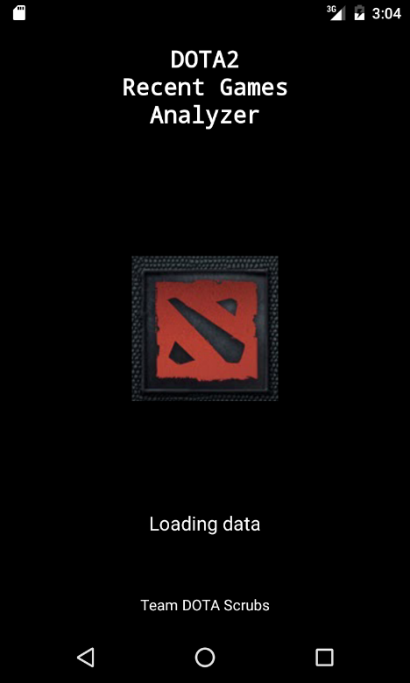 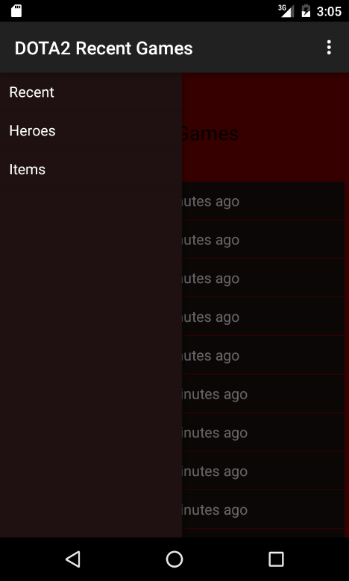 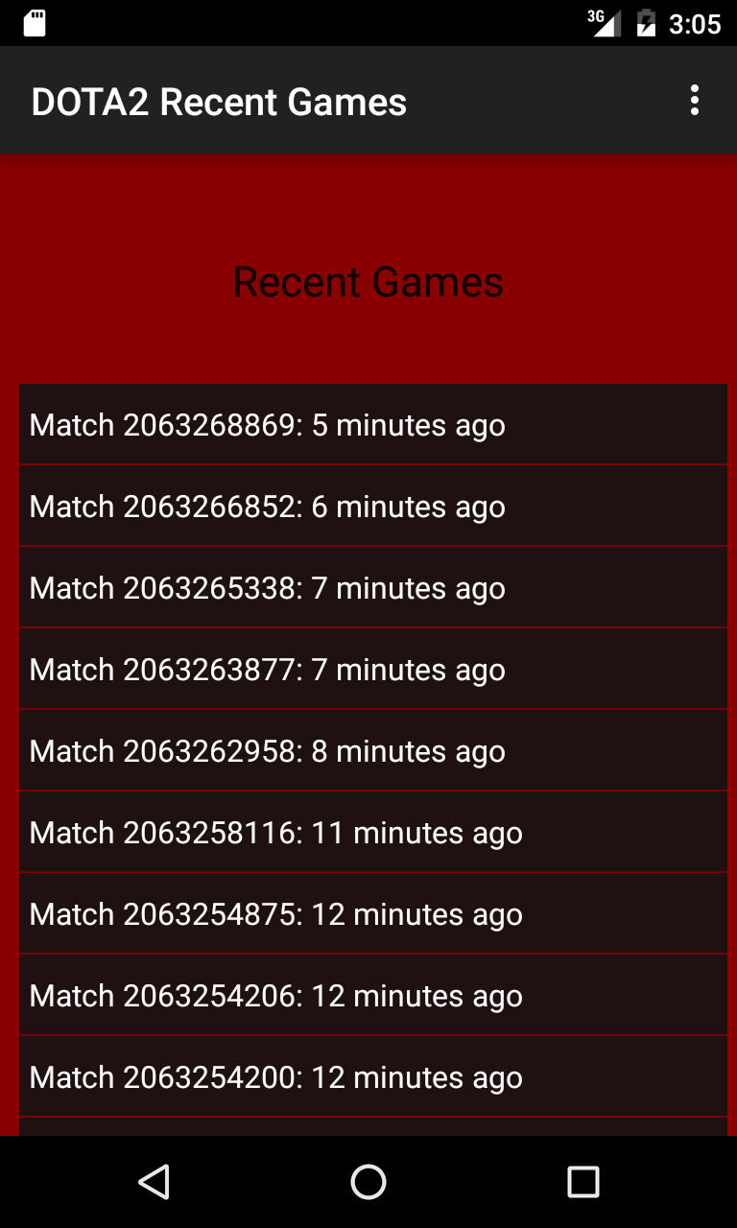

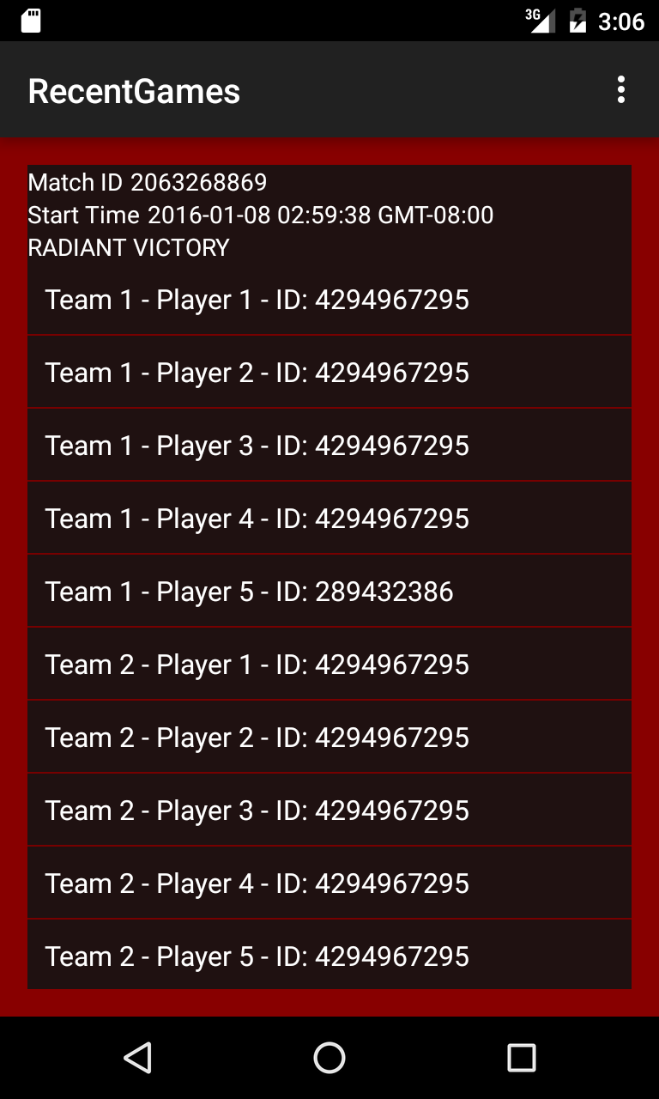 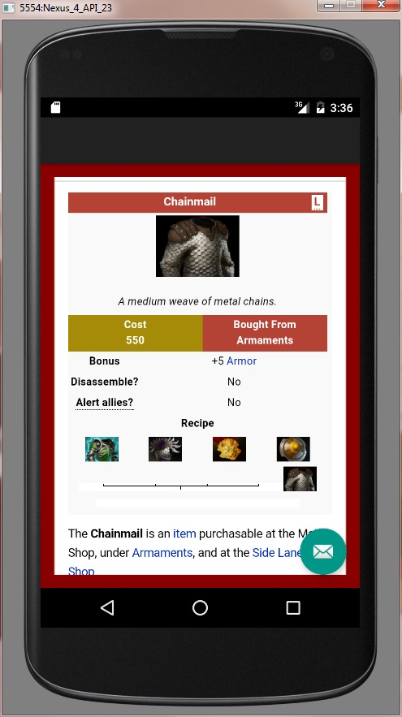

**Description:**

Quickly search and analyze recent DOTA2 games and brush up on your game knowledge! With our app checking out the meta game has never been easier. Results for recent games along with how each player did are available at your fingertips. You don’t need to tab out of your game to check a hero’s abilities, you don’t even need to type! Just scroll through the list and find what you need! Not completely sure how a hero or item interacts or is used? There’s an extra section for looking up your preferred hero and favorite items.

DOTA2 Recent Game Analyzer is designed for people who wants to get in shape with the current meta of the game Dota 2. We specialize the statistic of the game, most recent match information, items and heroes’ information as well as match’s detail.

DOTA2 Recent Game Analyzer is the best app to really help you to access the game’s mechanical data from your own mobile phone. Check out the features:

* Browse the most recent and useful matches DOTA2 games.
* Matches are updated automatically
* Use even while in game. There’s no need to tab out anymore!
* Select individual games for more specific information.
* Scroll through a list of heroes and learn about them.
* Scroll through a list of items and decide on your next purchase while in game.
* Strongly adapt with any Android version.

It’s time for you to start the game and archive higher rank MMR. Let us guide you through the DOTA2 Recent Game Analyzer.

**Notes:**

The Defense of the Ancients 2 (DOTA2) name and all related graphics belong to Valve. To play the game, go to: <http://store.steampowered.com/app/570/>

We are not associated or affiliated with Valve in any way.